**NAME: MOHAMMAD SHOAB**

**REG.NO: 20BCY10054**

**Campus: VIT Bhopal**

**Assignment: Bash Shell Basics**

**Task 1: File and Directory Manipulation**

1. Create a directory called "my_directory".
2. Navigate into the "my_directory".
3. Create an empty file called "my_file.txt".
4. List all the files and directories in the current directory.
5. Rename "my_file.txt" to "new_file.txt".
6. Display the content of "new_file.txt" using a pager tool of your choice.
7. Append the text "Hello, World!" to "new_file.txt".
8. Create a new directory called "backup" within "my_directory".
9. Move "new_file.txt" to the "backup" directory.
10. Verify that "new_file.txt" is now located in the "backup" directory.
11. Delete the "backup" directory and all its contents.

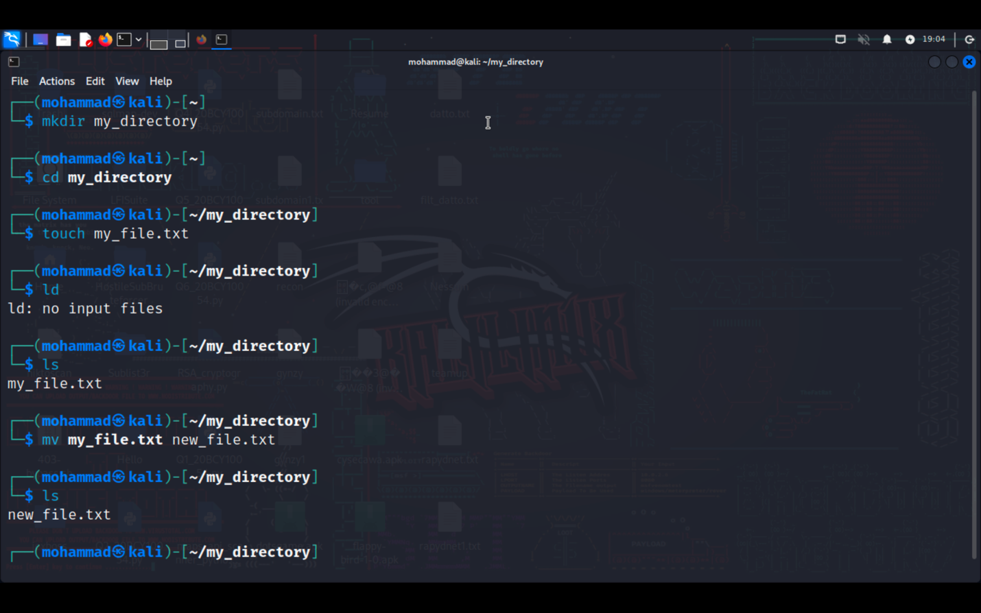

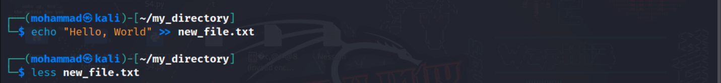

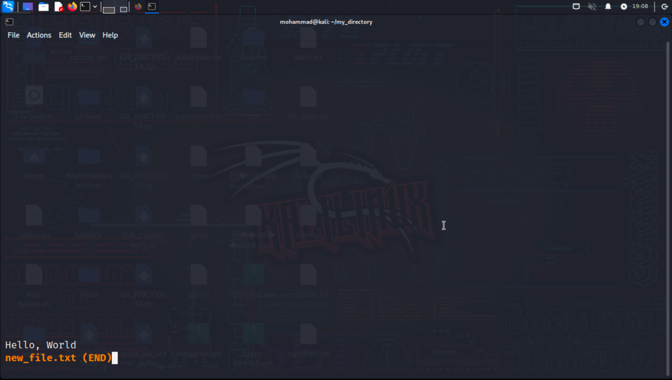

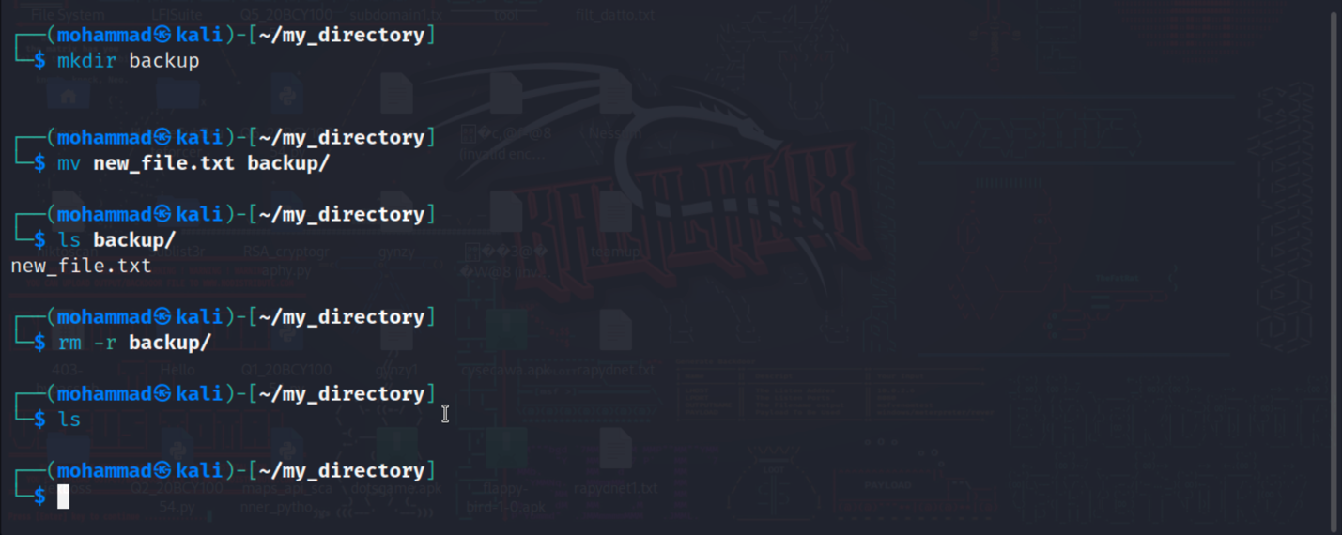

**Task 2: Permissions and Scripting**

* Create a new file called "my_script.sh".
* Edit "my_script.sh" using a text editor of your choice and add the following lines:

**#!/bin/bash**

**echo "Welcome to my script!"**

**echo "Today's date is $(date)."**

**Save and exit the file.**

* Make "my_script.sh" executable.
* Run "my_script.sh" and verify that the output matches the expected result.

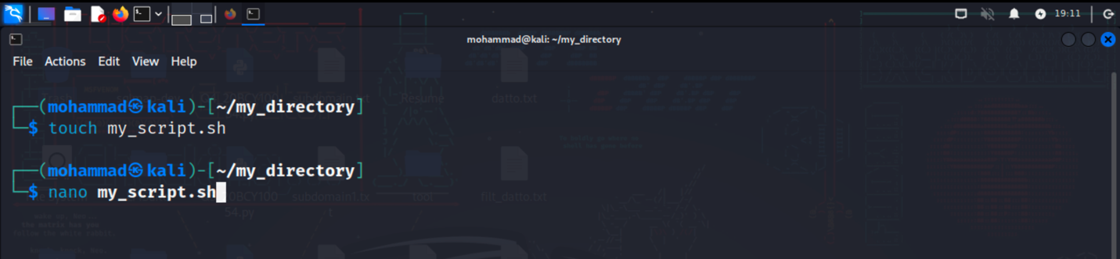

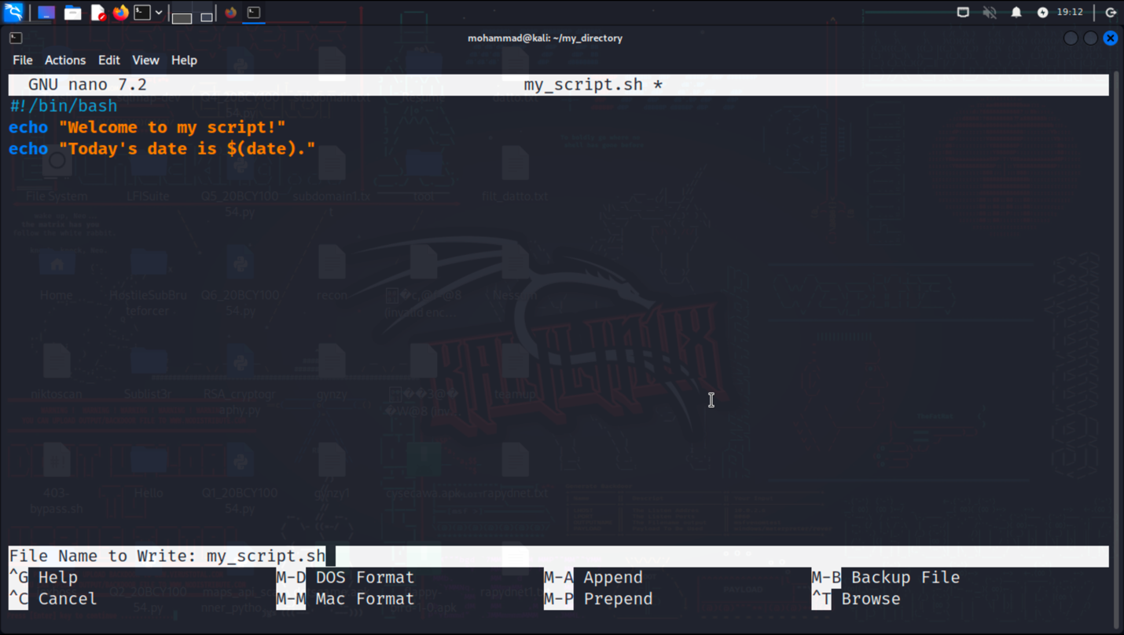

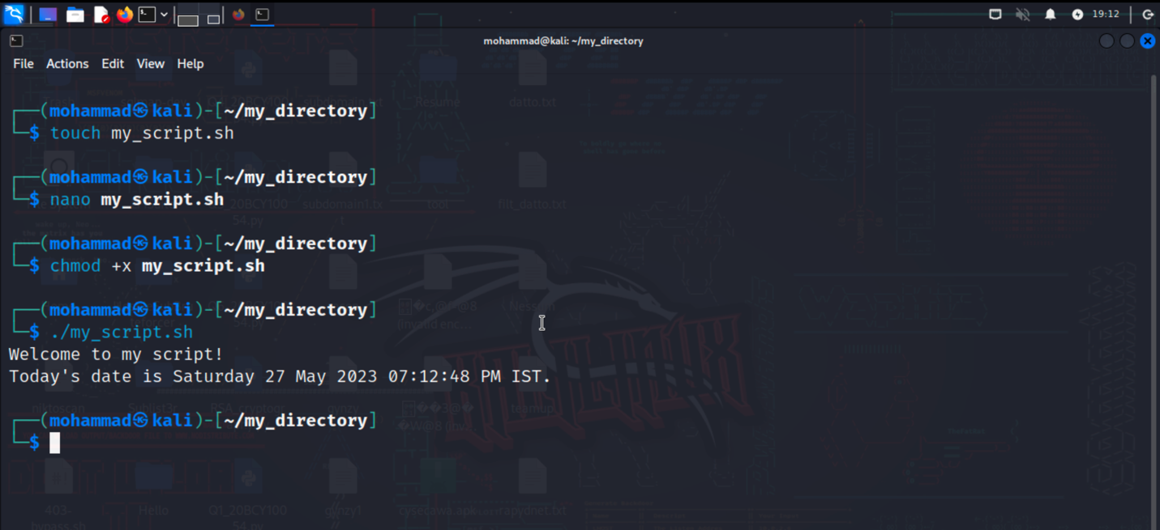

In this task, we have created a script file, add commands to display a welcome message and the current date, make the script executable, and then run it to ensure the output matches the expected result

**Task 3: Command Execution and Pipelines**

* List all the processes running on your system using the "ps" command.
* Use the "grep" command to filter the processes list and display only the processes with "bash" in their name.
* Use the "wc" command to count the number of lines in the filtered output.

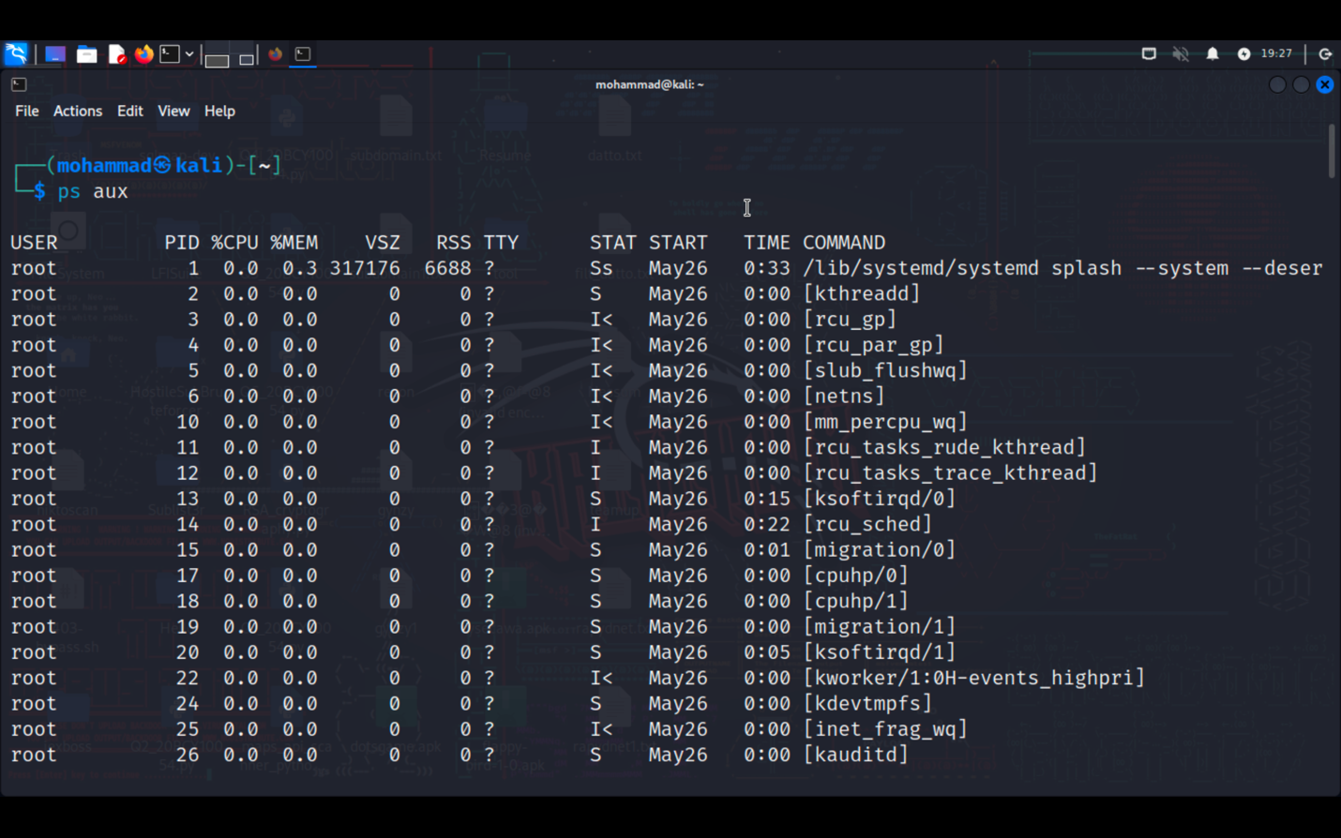

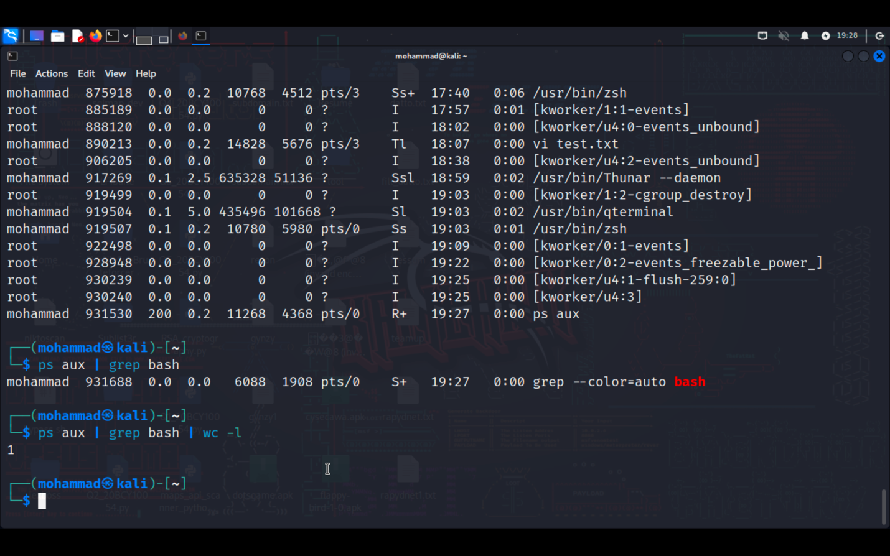

**Submission:**

Provide a document or text file containing the commands used to complete the tasks above, along with any relevant output or screenshots. Include your explanations or observations where necessary.